# Problem 3 – Black Messup

The scientists at Black Messup science facility are at the brink of major science breakthrough. The only problem is the software that isolates the strongest molecule made of bunch of atoms is really slow and they need an upgrade.

Each **molecule** is **made of connected atoms**. Each atom has a **name**, **mass** and **decay** period.

Each **atom** **decays for exactly one unit** **of time** and **should release its mass at or before its decay time**, e.g. if an atom has a decay time of 2, it can release its mass either at step 1 or step 2.

The **total force of a molecule** is calculated by getting the **maximized mass of all atoms that can decay in it**.

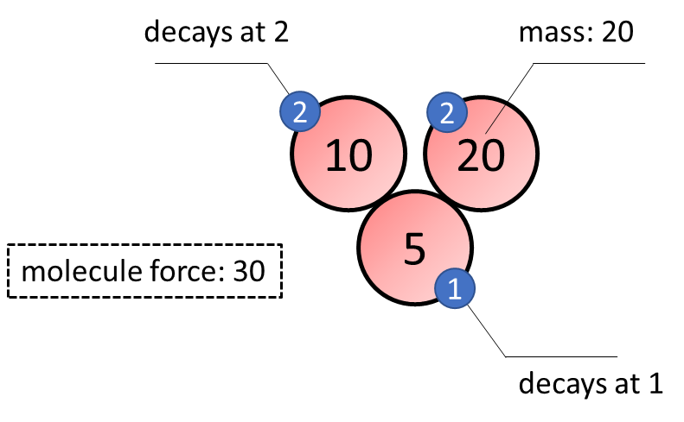

You need to **output the force** of the **strongest molecule** after a chain atom decay.

#### Input

* On the first line, you will get **N** - the number of atoms
* On the second line, you will get **K** - the number of connections between atoms
* On the next **N** lines are the atoms in format **{name, mass, decay}**
* On the next **K** lines are the connections in format **{from, to}**

#### Output

* Print the force of the strongest molecule after a chain atom decay

#### Constraints

* The count of atoms will be an integer in the range [**1…20000**].
* The count of connections will be an integer in the range [**1…20000**].
* Atoms will have mass in the range [**1…1000**].
* Atoms will have decay in the range [**1…1000**].
* Time limit: **100 ms**. Allowed memory: **32 MB**.

#### Examples

|  |  |  |
| --- | --- | --- |
| **Input** | **Output** | **Comment** |
| 3  1  Hydrogen 4 1  Argon 5 2  Iridium 7 1  Hydrogen Argon | 9 | First molecule has Hydrogen connected to Argon and total mass is Hydrogen 4 + Argon 5 = 9  Second molecule contains only Iridium and total mass is 7  Ouput the greater of the two. |
| 3  1  Hydrogen 4 1  Argon 5 1  Iridium 7 1  Hydrogen Argon | 7 | Argon and Hydrogen decay together. Only the one with greater mass is accounted (Argon 5).  Second molecule contains only Iridium that releases 7 mass. |
| 3  1  Hydrogen 4 2  Argon 5 2  Iridium 7 1  Hydrogen Argon | 9 | Hydrogen and Argon can release their mass together, it doesn’t matter which is first |